**Kickstart Campaign Analysis and Conclusions 2008-2014**

T/TH/S Class, Visualization and Data Analytics

November 7, 2019

Melissa Miller

1. 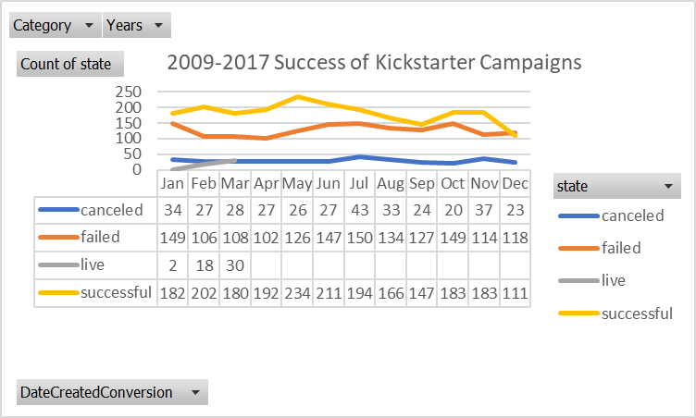

Over all (from Jan of 2009 through Mar 2017):

* + Jan through Mar: only campaign months for 2017
  + More successful campaigns than cancelled, failed or live
  + Top three best volumes: highest success was in May (234), Feb (202), July (194); lowest failure was in April (102), Feb (106), Mar (108)
  + Months of increased or consistent success and decreased failure: Jul, Apr, Nov
  + May through Sep: Peak and then steady decline of success; increase and then decrease in failure
  + Oct and Nov: stayed steady after a jump in success; a severe drop after a steep increase in failure
  + Dec: lowest success and highest failure

The chart reflects data for eight years (2009 through 2016) plus three months (2017: Jan, Feb, Mar). Hence, no campaigns were running during April through December of 2017. There was a 53 percent success rate and 37 percent failure rate overall. May had the highest success rate (61%) and February had the lowest fail rate (30%). December had the lowest success rate and highest failure rate.

If we throw the live counts out, the beginning of the year tends to have highest success rate and lowest failure rate. The total number of campaigns seem to be fairly consistent, except for the month of December. The number of total campaigns in December (252) is 15 percent lower than any other month (the second lowest volume month is September with 298 campaigns). The data suggests that people give more money at the beginning of the year and less money at Christmas time. We might conclude that tax season causes backers to give more money and Christmas causes them to not give money to the campaigns. The argument for the Christmas season as a time with less promise is strengthened when we look at December’s numbers in that December has the lowest percentage of sales and highest percentage of failures. We might conclude that less energy, time, and money be put toward December campaigns and put instead toward February, March, April, and May.

2. Limitations of this dataset: We aren’t given detailed geographic locations (we are given only the country) or demographics of the backers. This data could assist efforts on knowing how to adjust different campaigns and the marketing of them. Other interests of the potential backers and how they spend their money.

3. Other possible tables and/or graphs:

The success of each month of each year

Chart only success and failure

Create a regression line to show the future

Chart success rate by type of campaign, sub category, or by country